**SWIGGY FUNNEL ANALYSIS – Amal Thomas**

We are having swiggy traffic data and conversion data towards the sales. We need to identify orders with highs and lows with boarder value.

Concept of Orders = Traffic * Conversion

**Conditions**

* On weekends, Swiggy is getting extra orders naturally. Hence, we might see so many highs.
* We can ignore any difference of less than 20% and above -20% in orders from the same day last week. Hence, we can define highs or lows which are above 20% or lows below -20%

**Tasks**

1. Check if there is change in traffic as compared to same day last week o If there is change in traffic, identify the source of traffic change using Channel wise traffic sheet
2. Check if there is change in Overall Conversion as compared to previous dates. Break the overall conversion into smaller part in the following metrics, and create fresh columns on the following metrics in the Session Sheet L2M, M2C, C2P, P2O
3. Identify which one of the conversions is fluctuating

* Task - 1

|  |  |  |  |  |  |  |  |  |
| --- | --- | --- | --- | --- | --- | --- | --- | --- |
| **Date** | **Day name** | **Order Change** | **Traffic Change** | **Facebook Change** | **Youtube Change** | **Twitter Change** | **Others Change** | **Traffice change Reasons** |
| 10-01-2019 | Thursday | -45% | -49% | -95% | -49% | -49% | 15% | Face book traffic Drop |
| 17-01-2019 | Thursday | 106% | 110% | 1980% | 110% | 110% | -6% | Face book traffic Hike |
| 22-01-2019 | Tuesday | 85% | 77% | 77% | -65% | 747% | -60% | Twitter traffic Hike |
| 29-01-2019 | Tuesday | -72% | -40% | -40% | 198% | -88% | 166% | Huge changes in every traffic |
| 20-06-2019 | Thursday | -54% | -53% | -53% | -53% | -53% | -53% | All the traffics drop |
| 27-06-2019 | Thursday | 115% | 119% | 119% | 119% | 119% | 119% | All the traffics High |

* Task - 2

|  |  |  |  |  |  |  |  |  |
| --- | --- | --- | --- | --- | --- | --- | --- | --- |
| **Date** | **Day name** | **Order Change** | **Overall conversion Change** | **L2M change** | **M2C change** | **C2P change** | **P2O change** | **Conversion change Reasons** |
| 21-01-2019 | Monday | 23% | 17% | 2% | 7% | 9% | -2% | Overall Change in Conversion |
| 29-01-2019 | Tuesday | -72% | -52% | -55% | 8% | 2% | -5% | Huge drop at L2M |
| 05-02-2019 | Tuesday | 115% | 115% | 123% | -3% | -2% | 1% | Huge hike at L2M |
| 19-02-2019 | Tuesday | -56% | -54% | 1% | -57% | 1% | 4% | Drop at M2C |
| 26-02-2019 | Tuesday | 120% | 116% | -5% | 145% | -3% | -5% | Hike at M2C |
| 28-02-2019 | Thursday | 22% | 13% | 6% | 3% | -4% | 7% | Overall Change in Conversion |
| 02-03-2019 | Saturday | -38% | -42% | 0% | 5% | -49% | 7% | Drop at C2P |
| 09-03-2019 | Saturday | 102% | 102% | -1% | -1% | 112% | -3% | Hike at C2P |
| 19-03-2019 | Tuesday | -46% | -47% | 4% | 6% | 2% | -53% | Drop at P2O |
| 24-03-2019 | Sunday | 22% | 15% | 2% | 5% | 2% | 5% | Overall Change in Conversion |
| 26-03-2019 | Tuesday | 78% | 87% | -7% | -5% | -5% | 121% | Hike at P2O |
| 04-04-2019 | Thursday | -52% | -53% | 7% | -49% | -8% | -8% | Drop at M2C |
| 11-04-2019 | Thursday | 92% | 107% | -6% | 94% | 9% | 3% | Hike at M2C |
| 12-04-2019 | Friday | -27% | -20% | -7% | -7% | -5% | -4% | Small Drop at L2M &M2C |
| 14-04-2019 | Sunday | 28% | 19% | 4% | 3% | 4% | 6% | Overall Change in Conversion |
| 18-04-2019 | Thursday | 73% | 57% | -4% | 73% | -4% | -2% | Hike at M2C |
| 19-04-2019 | Friday | 25% | 16% | 2% | 8% | 5% | 0% | Overall Change in Conversion |
| 25-04-2019 | Thursday | -39% | -39% | 5% | -43% | -5% | 7% | Drop at M2C |
| 16-07-2019 | Tuesday | -63% | -59% | -60% | 0% | -1% | 2% | Drop at L2M |
| 23-07-2019 | Tuesday | 135% | 128% | 137% | 0% | 3% | -7% | Hike at L2M |
| 11-08-2019 | Sunday | -54% | -54% | 7% | 1% | -54% | -9% | Drop at C2P |
| 18-08-2019 | Sunday | 107% | 100% | -5% | 1% | 98% | 5% | Hike at C2P |
| 14-09-2019 | Saturday | -54% | -51% | 5% | -56% | 4% | 0% | Drop at M2C |
| 21-09-2019 | Saturday | 112% | 114% | -4% | 130% | -4% | 1% | Hike at M2C |
| 09-10-2019 | Wednesday | 22% | 27% | 7% | 1% | 9% | 7% | Small hike at L2M&P2O |
| 21-10-2019 | Monday | 32% | 21% | 2% | 7% | 4% | 6% | Small hike at M2C&P2O |
| 09-11-2019 | Saturday | 26% | 18% | -1% | 6% | 5% | 6% | Overall Change in Conversion |
| 17-11-2019 | Sunday | -57% | -54% | -1% | -58% | 7% | 3% | Drop at M2C |
| 24-11-2019 | Sunday | 135% | 124% | -1% | 150% | -8% | -2% | Hike at M2C |
| 01-12-2019 | Sunday | 21% | 20% | 4% | 1% | 6% | 7% | Overall Change in Conversion |
| 22-12-2019 | Sunday | 21% | 21% | 5% | 11% | 0% | 4% | Small hike at M2C |

**Here is the chart representation how the orders change with respect to traffic and conversion**

From the above graph it is visible that orders are changing with respect to traffic and conversion, also conversion is more influencing element for the order change

* Task 3

M2C is point where a greater number of fluctuations happening, swiggy need to solve the issues with the M2C part to increase the conversion rate

From the above chart it is visible that Conversion is more fluctuating than Traffic, 31 times in a year it is having changes and that affected orders.

**Final Analysis**

There are 36 dates in a year is having fluctuations, in those dates, orders having change due to change in conversion and traffic. The major reason behind traffic and conversion changes are,

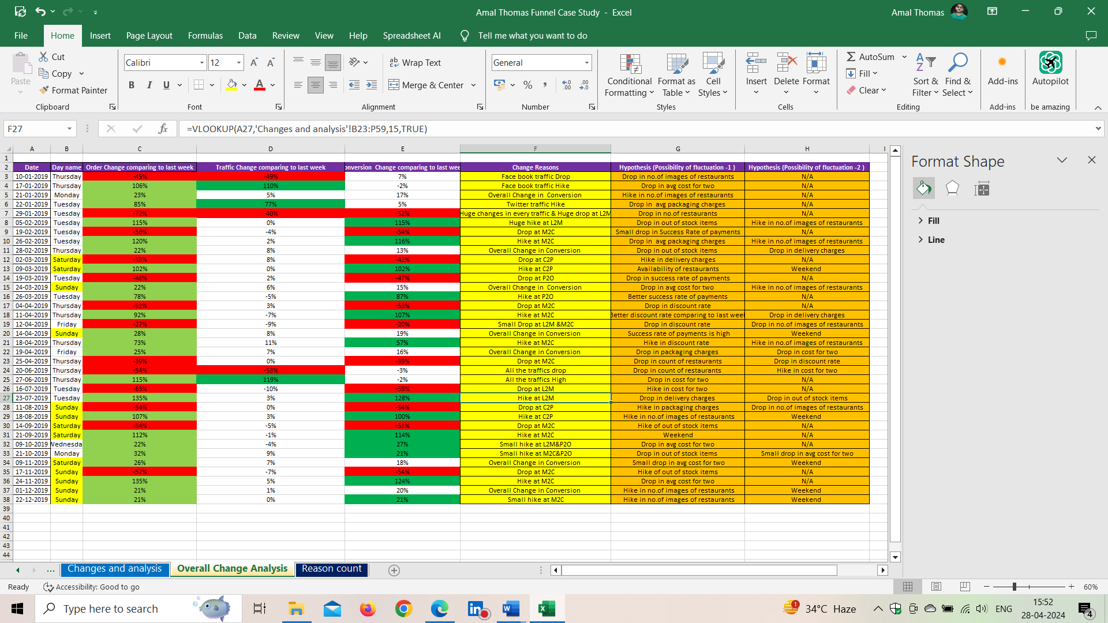

The same analysis has done in the excel sheet names {Overall change analysis}

These are major reasons behind traffic change and conversion. The conversion is having changes because of the various reasons inside the conversion funnel, i.e. L2M, M2C, C2P, P2O, all the reasons clearly mentioned in the above table and excel sheet.

**Suggestions**

* Give some extra attention to M2C part where the most of the changes occurs
* Packaging and delivery charges should be low or should maintain an average amount to avoid the reduction of orders
* Discount should provide in a better way to attract more customers
* Mandatory to reduce out of stock items per restaurants, this will meet customers needs and provide better growth in orders
* Many of the customers are focusing on average amount of 2 items, if its affordable then definitely customers go with those orders
* Try to fill maximum product images per restaurants in the swiggy application or web to gain maximum attention of customers
* Try to monitor traffic conversions in every 3 months to know the best and worst traffic and this will help swiggy to concentrate more on best traffics and avoid worst traffic channels.
* Proving better payment and order experience to customers will increase the conversion rate from P2O.